Collections in C#
Collections in C# are used to store, manage, and manipulate groups of objects. They provide more flexible ways to work with groups of objects compared to arrays, as collections can dynamically grow and shrink in size and offer various utility functions for adding, removing, and searching for elements.
C# provides a variety of collection types under the System.Collections and System.Collections.Generic namespaces. Let's explore the most common ones with examples.

1. ArrayList
ArrayList is a non-generic collection that can store objects of any data type. It is dynamic in size and allows adding or removing elements at runtime. However, it's slower and less type-safe compared to generic collections like List<T>.
- Namespace: System.Collections
- Key Features:
  - Stores objects as Object.
  - Not type-safe.
  - Resizable.
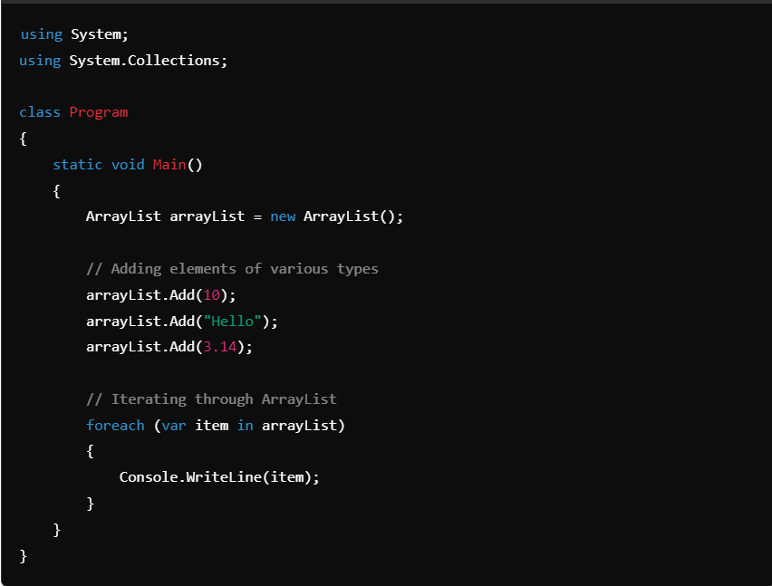
Output:
10
Hello
3.14
- Limitations:
  - Type casting is required when accessing elements.
  - Potential for runtime errors due to type mismatches.

2. List<T> (Generic)
List<T> is a generic collection that provides type safety and performance advantages over ArrayList. It allows you to store elements of a specific type, ensuring that type checking happens at compile-time.
- Namespace: System.Collections.Generic
- Key Features:
  - Type-safe.
  - Resizable.
  - Provides various utility methods like Add(), Remove(), Find(), etc.
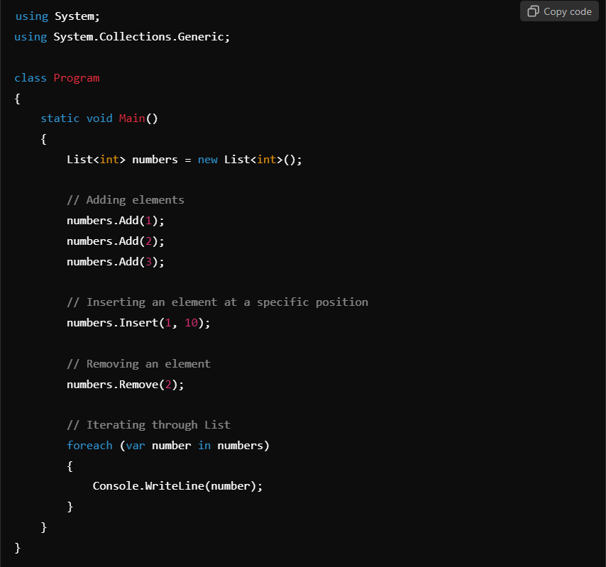
Output:
1
10
3
- Advantages:
  - Type-safe: Elements must be of type T.
  - Performance: No boxing/unboxing (in case of value types).

3. Dictionary<TKey, TValue>
A Dictionary is a collection that stores key-value pairs. It is used when you want to associate a value with a unique key and retrieve values efficiently using the key.
- Namespace: System.Collections.Generic
- Key Features:
  - Key-based access.
  - Fast lookups.
  - Keys must be unique.
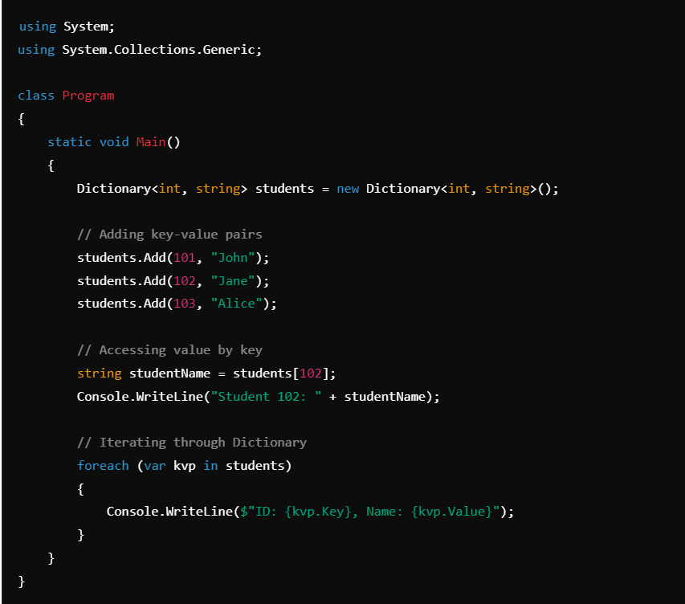
Output:
Student 102: Jane
ID: 101, Name: John
ID: 102, Name: Jane
ID: 103, Name: Alice
- Advantages:
  - Fast lookups based on keys.
  - Keys must be unique.
- Use Cases:
  - Associating student names with IDs.
  - Storing configuration settings.

4. Queue<T>
A Queue is a first-in, first-out (FIFO) collection where elements are added to the back and removed from the front. It's useful in scenarios like task scheduling or when you need to process elements in the order they arrive.
- Namespace: System.Collections.Generic
- Key Features:
  - FIFO (First-In-First-Out) behavior.
  - Enqueue() to add, Dequeue() to remove.
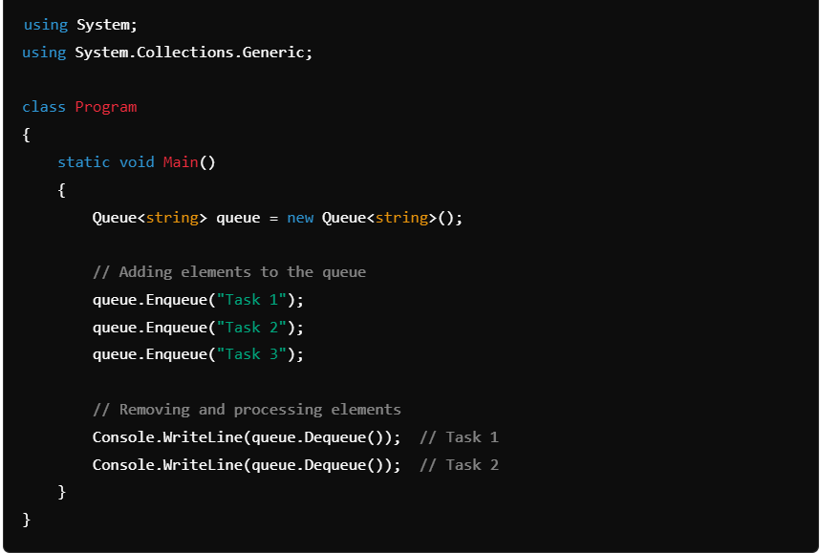
Output:
Task 1
Task 2
- Advantages:
  - Processes elements in the order they were added.
- Use Cases:
  - Task scheduling.
  - Job processing.

5. Stack<T>
A Stack is a last-in, first-out (LIFO) collection where elements are added to and removed from the top. It is used in scenarios where you need to reverse items or undo operations.
- Namespace: System.Collections.Generic
- Key Features:
  - LIFO (Last-In-First-Out) behavior.
  - Push() to add, Pop() to remove.
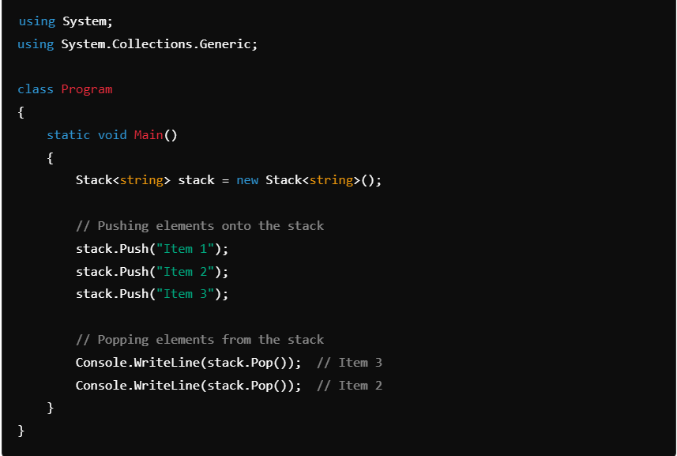
Output:
Item 3
Item 2
- Advantages:
  - Reverses the order of elements.
- Use Cases:
  - Undo operations.
  - Reversing data.

6. HashSet<T>
A HashSet is a collection that contains unique elements, meaning duplicates are not allowed. It's often used when you need to maintain a collection of unique values.
- Namespace: System.Collections.Generic
- Key Features:
  - No duplicate elements.
  - Fast lookups for membership tests.
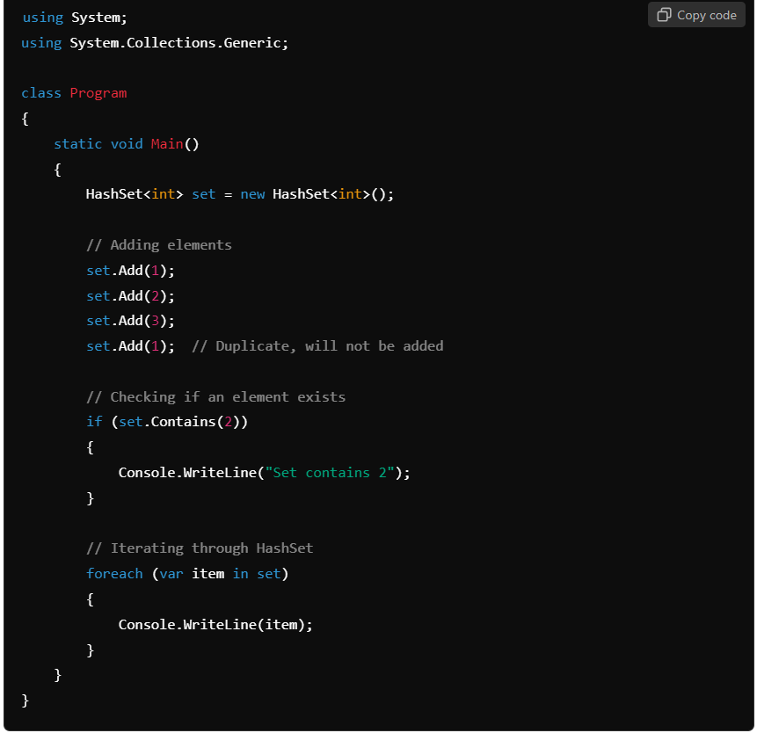
Output:
Set contains 2
1
2
3
- Advantages:
  - Ensures uniqueness.
  - Fast lookups.
- Use Cases:
  - Storing unique IDs.
  - Checking for duplicates.

7. LinkedList<T>
A LinkedList is a doubly linked list, where each node contains a reference to the next and previous node. It allows for efficient insertions and deletions at any point in the list.
- Namespace: System.Collections.Generic
- Key Features:
  - Fast insertions and deletions.
  - Supports traversal in both directions (forward and backward).
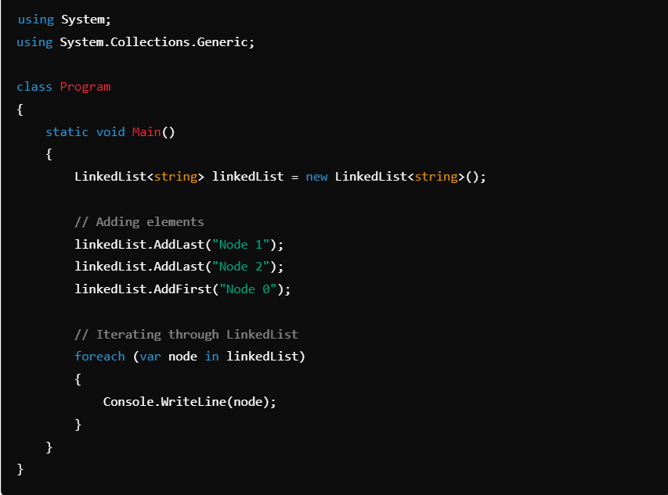
Output:
Node 0
Node 1
Node 2
- Advantages:
  - Efficient insertions and deletions at any position.
- Use Cases:
  - Implementing stacks, queues, and deques.
  - Manipulating elements in the middle of a list.

Conclusion:
C# provides a rich set of collection types, each suited for different scenarios:
- ArrayList for non-generic collections.
- List<T> for type-safe, resizable collections.
- Dictionary<TKey, TValue> for key-value mappings.
- Queue<T> and Stack<T> for FIFO and LIFO processing, respectively.
- HashSet<T> for maintaining unique elements.
- LinkedList<T> for efficient insertions and deletions.
Choosing the right collection depends on your specific use case, such as whether you need fast lookups, ordered elements, or unique values.

